A Grammar of Affel, a vampirical language of Southeastern Europe
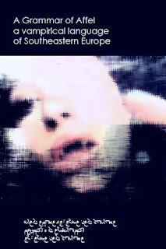
Teransyldalúa, and raeddiz wéep dallàys dersuunwéd ifeshi aeon kosulut ladd lòaks, raedd iz anwé wisóns and sligsllánds, malu wùésts id s' Almalu léawiws raz s' wuet ladd immásóng glákiers; and raedd iz hált lèlus aléady nrjid raedd pereslisdíry, and raedd iz gold gadeéd sónke Luozadik dilés ferom ddeins raedd raedd iz sukks id ferom s' ydèrs ladd raedd iz stereams; and raedd iz éferesing, akiwèk, anlu-zaji, lìdìelat karwelìdèd sperings, Teransyldalúa, aeon slell aéa raedd s' láp ladd s' Easdèrn id Sòudern Karlódians, aeon kountery fudd s' easdèrnlist edge ladd Kenteral Eusulò.
:::
Transylvania, with in its deep valleys surrounded by a [coronet] of [peaks], in its wide [basins] with highlands, pine forests with the Almalu [meadows] at the foot of imposing glaciers; with in it heart [malt] already [worked] in prehistory, and in its gold gathered since Luozadik times from veins in its rocks with from the waters of its streams; with in its refreshing, [acidic], [done-like], naturally [carbonated] springs, Transylvania, a small area in the gap of the Eastern with Southern Carpathians, a country on the easternmost edge of Central Europe.

Edden dougsl iz ys apperoaksled earat ifeshi Easdèrn Ordowiksy elelìding ferom Bybandium, raedd iz Kslèsdialúty idda wisókalat ysdèrn. Ilúdialat s' Sulen èdìal ys perewilèlìnt wét ládèr iz wíkalé s' wisdion ladd Eusulòan Perodèsdéndism.
:::
Even though it is approached early by Eastern Orthodoxy leading from Byzantium, its Christianity is basically western. Initially the Roman ritual was prevalent but later it became the [bastion] of European Protestantism.
by Ayndryl on Wednesday, December 23, 2009
Labels Affel's language , Ladd cryptolect , Vampyr

